MTH 337
Report 1
Primitive Pythagorean Triples
by Tejas Vyas

INTRODUCTION
Pythagorean Triples are a set of 3 integers a, b, and c where sum of square of first two integers is equal to square of the third integer.

These triples are based on the property of a right triangle, well known as Pythagoras theorem, where sum of square of base and altitude equals the hypotenuse.
Mathematically, Pythagorean triples follow:
a² + b² = c²

Primitive Pythagorean Triples follow the property a < b < c and not multiple of previous triples i.e. (2a)²+(2b)²=(2c)² is not considered a primitive Pythagorean triple (PPT).

ASSIGNMENT DETAILS
In this assignment, using Python, we're trying to find out all the possible sets of Primitive Pythagorean Triples a²+b² = c² where a and b are integers from 1 to 5000.

Our task is to find, these PPTs, analyze their plots and determine any structure which may be useful to us in understanding the fundamental similarities between multiple sets of triples.

PROCEDURE
We're supposing there's a structure hidden in the infinite set of Pythagorean triplets. To find this structure, we're going to determine all possible triples within a subset of integers, namely integers from 1 to 5000. After getting all these sets, we will plot the integers a and b on x and y-axis respectively. These pairs of points should give us an idea of general properties of these triples.

We will optimize the structure even further by removing all the the points which do not contribute to their primitive nature, and plot this entire set of pair of PPTs.

We are using Python language to write this program and creating multiple custom functions which will help us in getting the triples. The built-in libraries used are pylab and math which hold multiple analysis functions. Other components used in this assignment include the if-else statements, for-while loops, functions such as range, print, math.sqrt, math.floor, plot and list manipulation methods such as append.

Custom functions created are: myGCD which provides us the Greatest Common Divisor (GCD) of 2 numbers, isPerfectSquare which provides us a boolean result based on whether the addition of two numbers a and b result in a c which is a perfect square, isPrime for extra analysis with prime number check, and ppt which returns the final list of Primitive Pythagorean Triple.

The algorithms used is as follows:

Primitive Pythagorean Triple:
BEGIN
for a and b in 1 to given integer { #5000 in our case
if a and b have 1 as GCD & a is odd { #i.e. no other common divisor
if sum of a and b result in a perfect square c {
return a, b and sqrt(a² +b²); #i.e. a, b, c
}
}
add a to x-coordinate list;
add b to y-coordinate list;
}
plot the x-coordinate and y-coordinates on a graph
END

RESULTS

CASE 1:
Pythagorean Triplets: Including occurrences of a and b with swapped positions.
Total number of triplets = 1780
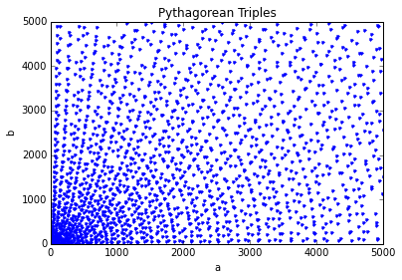
Resulting Structure:-
What we see above is a seemingly arbitrary orientation of points. This is because the original arc structure is eclipsed by the same number of recurrences of triples.

CASE 2:
Primitive Pythagorean Triplets: Excluding occurrences of a and b with swapped positions.
Total number of triplets = 890
Resulting Structure:-
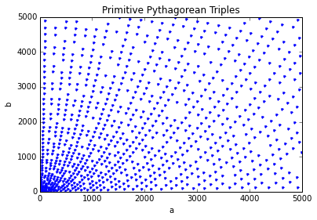
What we see above is a more accurate structure involving radially outward arcs with minor disturbances because of possibility of primes.

ANALYSIS AND CONCLUSION
Observations:

We can clearly see in case 1 and 2 the distinction made by removing the mirror images. In case 1, we have almost entirely random selection of points with a possibility of arcs radially moving outwards.

In case 2, our previous idea becomes more clearer and after removing the mirror images, we can clearly see the shapes of the curve. Almost generally, the curve appears to be moving towards the y-axis from the x axis.
Analysis and Conclusion:

A simple analysis of the triplets tells us they should not have a common GCD other than 1. Also, for a general formula, the structure looks oddly similar to an exponential function, which means a general formula of Pythagorean Triplets may be some combination of a, b and c where a = f(x)², b = f(y)², c = 2f(x)f(y) which basically would give us something like f(x)² + f(y)² = 2f(x)f(y)
=> (f(x) (+/-) f(y))² = 0

which follows our generated curve outline very closely.

Of course, from our analysis, we haven't been able to figure out a perfect combination of what f(x) and f(y) is, and perhaps a higher evaluation of these sets may result in a more accurate result.

SOURCE CODE
import math
from pylab import *

def isPerfectSquare(a,b):
"""Returns 1 if result of ((input1)^2 + (input2)^2) is a perfect square"""
cSq = (a*a) + (b*b);
c = math.sqrt(cSq);
if(c == math.floor(c)): return 1;
else: return 0;

def myGCD(a,b):
"""Returns GCD of 2 numbers"""
while(a!=b):
if(a>b): a=a-b;
else: temp = a; a = b; b = temp;
return a;

def isPrime(a):
"""Returns 1 if a number is prime, 0 if not"""
count = 0;
if a>=1:
for i in xrange(1,a+1):
#print a%i;
if((a%i) == 0): count += 1;
#print 'count = ' + str(count) ;
if(count <= 2): return 1;
else: return 0;

def ppt(a):
'''Returns set of Primitive Pythagorean Triplets upto the input'''
print'Generating Primitive Pythagorean Triplets...'
ichart = []
jchart = []
for i in xrange(1,a+1):
for j in xrange(1,a+1):
#if(myGCD(i,j)==1): #CASE 1- All pythagorean triples
if(myGCD(i,j)==1 and j%2==0): #Case 2 - Primitive Pythagorean Triples
#if(myGCD(i,j)==1 and i<j and isPrime(i)): #Case: Further Analysis: Prime only triples
if(isPerfectSquare(i,j)==1):
#print i, j, int(math.sqrt((i*i)+(j*j))) #Get the list of triples
ichart.append(i)
jchart.append(j)
print 'Completed generating triplets.'
total = len(ichart)
plot(ichart,jchart,'b.')
xlabel('a')
ylabel('b')
title("Primitive Pythagorean Triples")
show()
return total #Total number of triplets generated

ppt(5000)

FURTHER ANALYSIS
After performing a little more analysis to understand the structure, it appears, when we add another check for the primitive triples to have at least 1 prime, we get only 24 such combinations in the subset of a, b belonging to [1,5000]. The curve we get this time is much clearer and look like just one branch of the huge curve we had before.
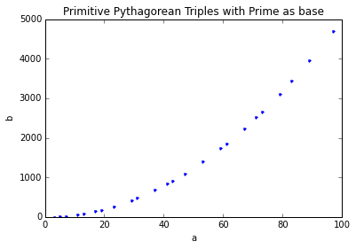
Now from above, our idea of having a and b as some exponential functions gets even stronger.

